**HOME AUTOMATION WITH SMOKE SENSOR, MOTION SENSOR AND BLUETOOTH SENSOR**

**Made by:**

**=>YASH VARA [56]**

**=>KEVAL BEHERA [39]**

**---------------------------------------------------------------------------------**

**Apparatus:**

1] Arduino UNO

2] jumper wire

3] Bluetooth sensor

4] IR sensor

5] MQ2 (smoke sensor)

6] BOX

7] LED

8] FAN

**Sensors used in the project:**

1] Bluetooth sensor

2] IR sensor

3] MQ2 (smoke sensor)

**Working principal of the sensors:**

1] Bluetooth sensor

=> Bluetooth works by the simple principle of sending and receiving data in the form of radio waves.

2] IR sensor

=> There are different types of infrared transmitters depending on their wavelengths, output power and response time. An IR sensor consists of an IR LED and an IR Photodiode, together they are called as Photo-Coupler or Opto-Coupler.

3] MQ2 sensor

=> This sensor contains a sensing element, mainly aluminium-oxide based ceramic, coated with Tin dioxide, enclosed in a stainless-steel mesh. Sensing element has six connecting legs attached to it. Two leads are responsible for heating the sensing element, the other four are used for output signals.

**About the project:**

* **Bluetooth sensor (HC-05)**

HC-05 has red LED which indicates connection status, whether the Bluetooth is connected or not. Before connecting to HC-05 module this red LED blinks continuously in a periodic manner. When it gets connected to any other Bluetooth device, its blinking slows down to two seconds.

This module works on 3.3 V. We can connect 5V supply voltage as well since the module has on board 5 to 3.3 V regulator.

As HC-05 Bluetooth module has 3.3 V level for RX/TX and microcontroller can detect 3.3 V level, so, no need to shift transmit level of HC-05 module. But we need to shift the transmit voltage level from microcontroller to RX of HC-05 module.

To communicate smartphone with HC-05 Bluetooth module, smartphone requires Bluetooth terminal application for transmitting and receiving data. You can find Bluetooth terminal applications for android and windows in respective app. store.

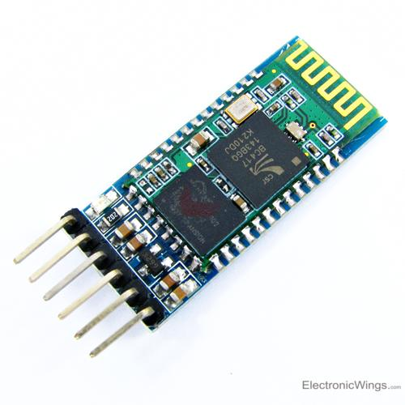

* **IR sensor**

IR sensor is an electronic device, that emits the light in order to sense some object of the surroundings. An IR sensor can measure the heat of an object as well as detects the motion. Usually, in the infrared spectrum, all the objects radiate some form of thermal radiation. These types of radiations are invisible to our eyes, but infrared sensor can detect these radiations.

The emitter is simply an IR LED (Light Emitting Diode) and the detector is simply an IR photodiode. Photodiode is sensitive to IR light of the same wavelength which is emitted by the IR LED. When IR light falls on the photodiode, the resistances and the output voltages will change in proportion to the magnitude of the IR light received.

There are five basic elements used in a typical infrared detection system: an infrared source, a transmission medium, optical component, infrared detectors or receivers and signal processing. Infrared lasers and Infrared LED’s of specific wavelength used as infrared sources.

There are two types of IR sensors are available and they are,

A] Active Infrared Sensor

B] Passive Infrared Sensor

=>Active Infrared Sensor

Active infrared sensors consist of two elements: infrared source and infrared detector. Infrared sources include the LED or infrared laser diode. Infrared detectors include photodiodes or phototransistors. The energy emitted by the infrared source is reflected by an object and falls on the infrared detector.

=>Passive Infrared Sensor

Passive infrared sensors do not use any infrared source and detector. They are of two types: quantum and thermal. Thermal infrared sensors use infrared energy as the source of heat. Thermocouples, pyroelectric detectors and bolometers are the common types of thermal infrared detectors. Quantum type infrared sensors offer higher detection performance. It is faster than thermal type infrared detectors

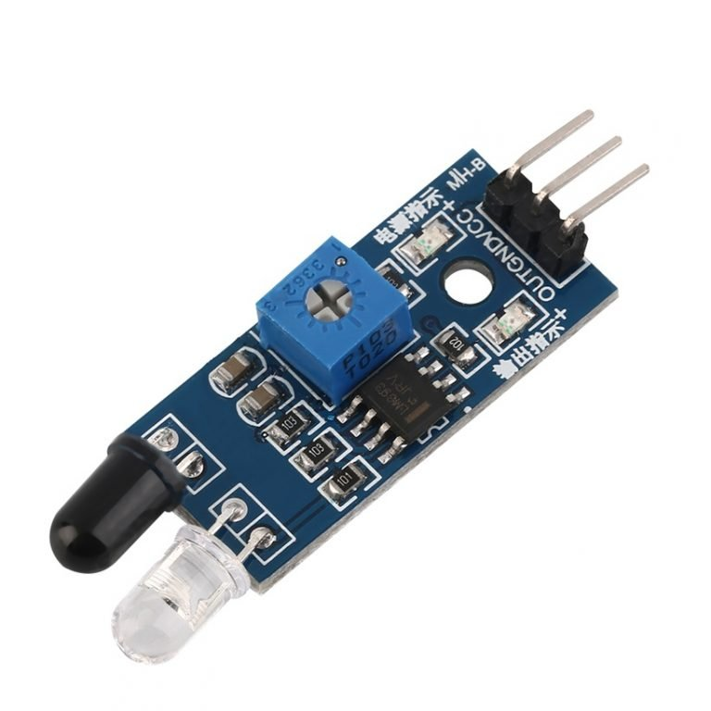

* **MQ2 (smoke sensor)**

MQ2 gas sensor is an electronic sensor used for sensing the concentration of gases in the air such as LPG, propane, methane, hydrogen, alcohol, smoke and carbon monoxide.

MQ2 gas sensor is also known as chemiresistor. It contains a sensing material whose resistance changes when it comes in contact with the gas. This change in the value of resistance is used for the detection of gas.

MQ2 is a metal oxide semiconductor type gas sensor. Concentrations of gas in the gas is measured using a voltage divider network present in the sensor. This sensor works on 5V DC voltage. It can detect gases in the concentration of range 200 to 10000ppm.

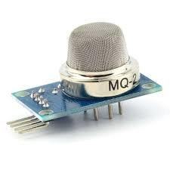

We have also used transistor (BC457) in this project as it will turn on the led.

Transistor is a type of a semiconductor device that can be used to both conduct and insulate electric current or voltage. A transistor basically acts as a switch and an amplifier. In simple words, we can say that a transistor is a miniature device that is used to control or regulate the flow of electronic signals.

BC547 NPN transistor drives Led at the output as it detects a fire. The working of a smoke sensor is quite easy and simple. The transistor turns on whenever it gets the base voltage of 0.7V through the resistor. As the circuit senses the smoke it decreases the resistance at the base. Due to which the voltage across the base terminal increases or becomes equal to 0.7V which turns the transistor ON. The Led starts glowing to indicate the smoke. When there is no smoke, the led turns Off as the voltage across the base terminal falls below 0.7V so the transistor turns off.